Aim: To perform data analysis using Microsoft Excel.

Theory:

Q1. What is Microsoft Excel?
Microsoft Excel is a powerful spreadsheet application developed by Microsoft. It is used for organizing, storing, calculating, analyzing, and visualizing data. Excel provides features like formulas, functions, charts, pivot tables, sorting, filtering, and conditional formatting to manage data efficiently.

Q2. What is data analysis?
Data analysis is the process of inspecting, cleaning, transforming, and modeling data to discover useful information, draw conclusions, and support decision-making. In Excel, data analysis involves using tools like sorting, filtering, pivot tables, charts, and formulas to identify patterns, trends, and insights from raw data.

Q3. What is the purpose of sorting and filtering?
- Sorting arranges data in a specific order (ascending or descending) based on one or more columns. This helps in organizing data alphabetically, numerically, or by date for easier viewing and comparison.
- Filtering displays only the rows that meet certain conditions while hiding the rest. This helps in focusing on specific subsets of data, such as showing only students who scored above 80 marks or sales in a particular region.

Q4. What is a Pivot Table?
A Pivot Table is an interactive Excel tool that summarizes and analyzes large datasets dynamically. It allows users to reorganize, group, aggregate (sum, count, average), and compare data without changing the original dataset. Pivot Tables are useful for creating quick reports and identifying patterns from complex data.

Q5. Name any two Excel functions and their use.
- LEN() – Counts the number of characters in a cell. For example, `=LEN("Hello")` returns 5. It is useful for validating data length, such as checking if a phone number or ID has the correct number of digits.
- IF() – Performs a logical test and returns one value if the condition is true and another value if false. For example, `=IF(A1>75, "Pass", "Fail")` returns "Pass" if the value in cell A1 is greater than 75, otherwise "Fail". It is useful for grading, categorizing data, or creating conditional outputs.

Q6. What is conditional formatting?
Conditional formatting is an Excel feature that automatically applies formatting (such as colors, icons, or data bars) to cells based on specific conditions or rules. For example, you can highlight all cells with values above 80 in green or below 35 in red. It helps in visually identifying trends, outliers, or important data points at a glance.

Q7. Perform data analysis using Excel on a dataset.
Open Excel and load a dataset.
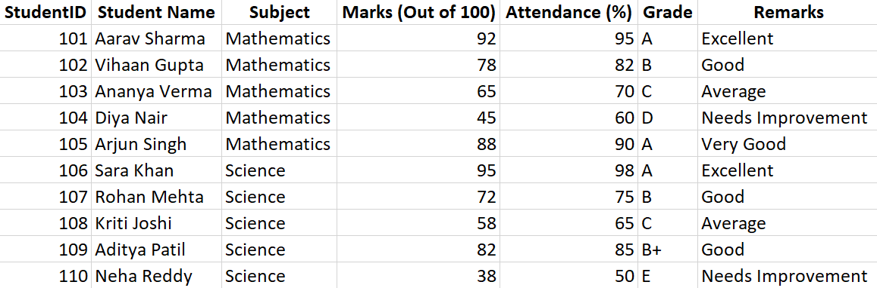

Perform sorting (ascending/descending).
Ascending

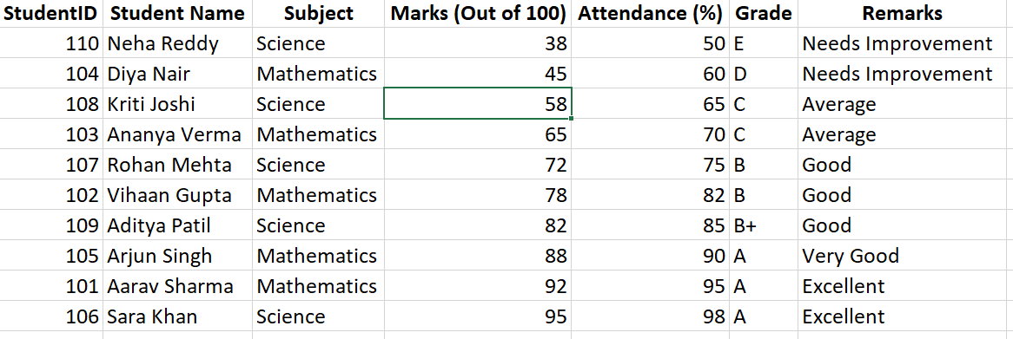

Descending

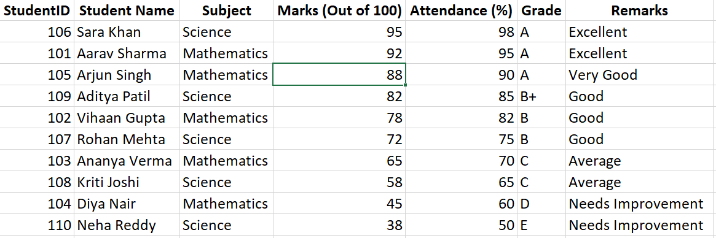
Apply filters to the dataset.
Filter by only Science

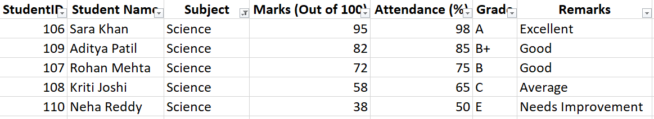

Filter by only grade A

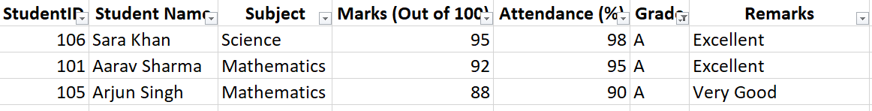

Use conditional formatting (Greater than / Less than).
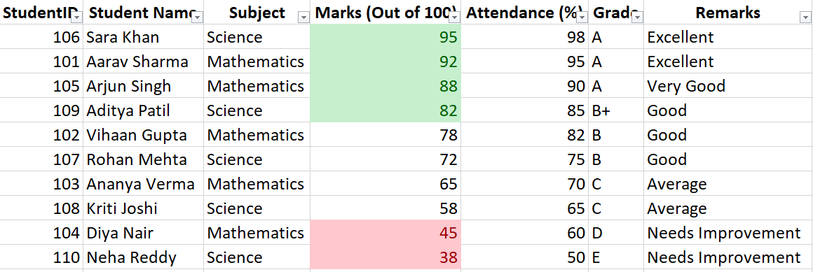

Apply Data Bars.
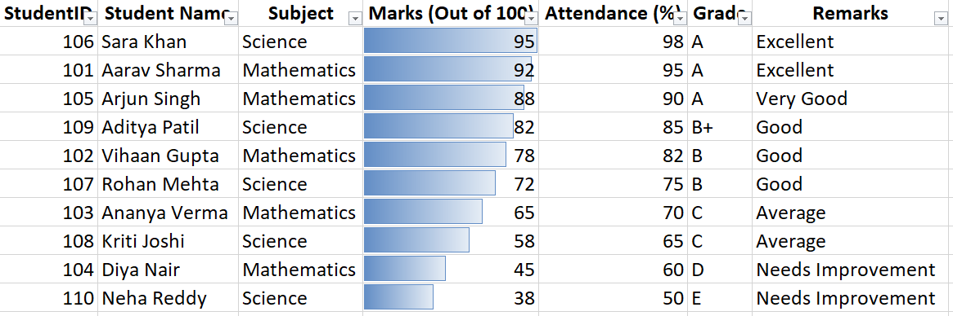
Apply Color Scales.
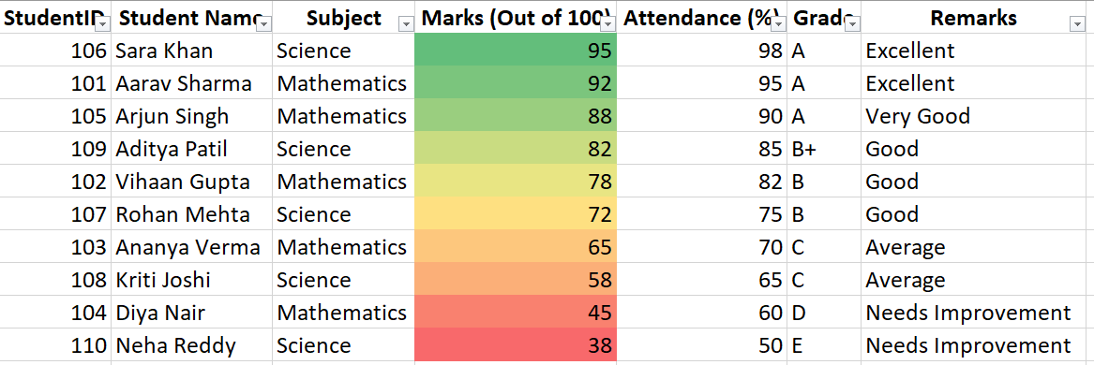

Remove duplicate values.
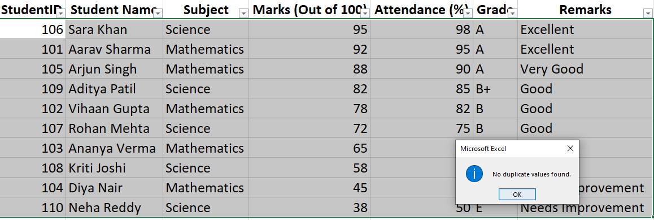

Create a Pivot Table for analysis.
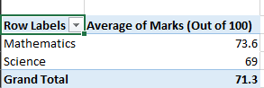 Average of student marks
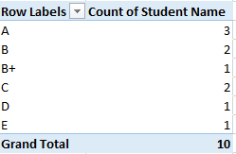 Grade of students sumed

Use functions like IF(), LEN(), or CONCATENATE().
=IF(D2>=50, "Pass", "Fail")

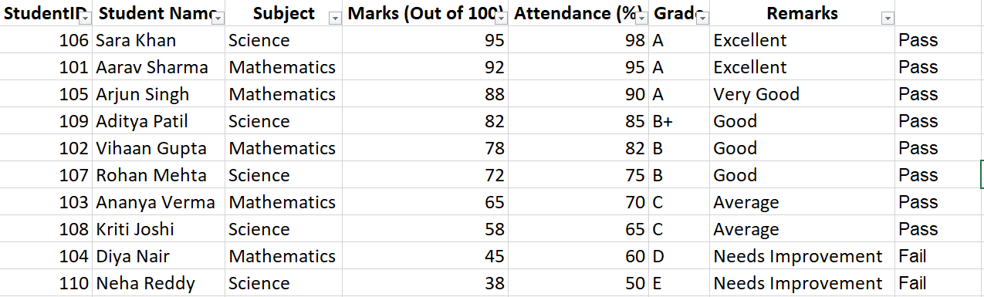

=LEN(B2)
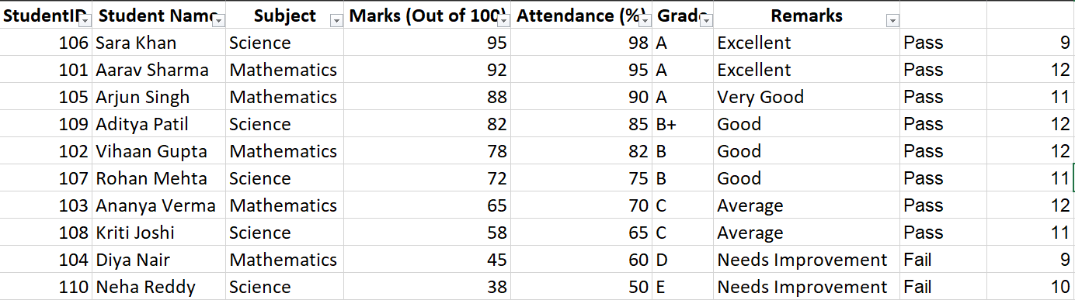

=CONCATENATE(B2, " - ", F2)

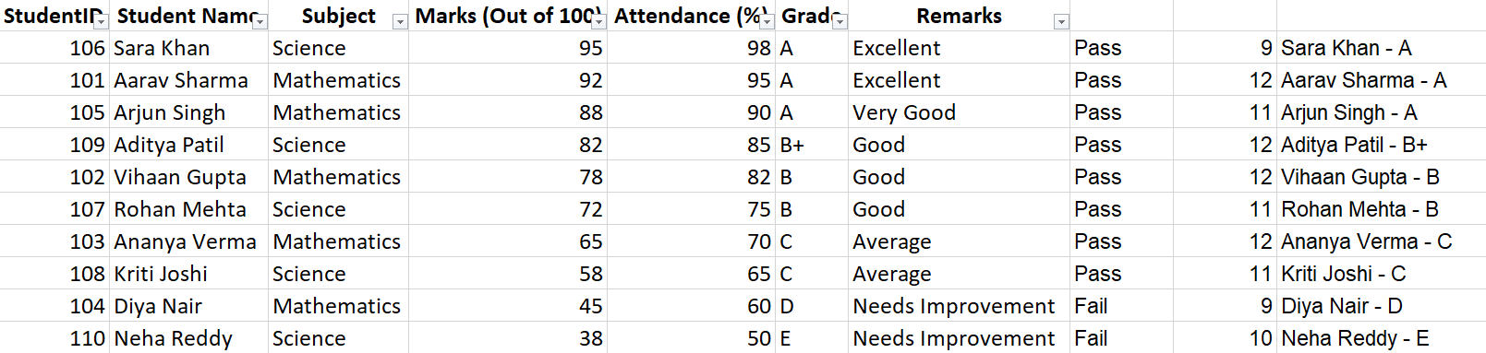

Conclusion:
Successfully performed data analysis using Microsoft Excel.

